Community Emergency Plan

Lydford

March 19th 2020 / Version 2
Redacted

DEVON COMMUNITY RESILIENCE FORUM

Amendments
Date | Page number | Reason for amendment | Changed by

Contents
1. Community Response Team 4
2.1 Responsibilities 5
2. Related emergency planning 5
3.1 Arrangements between emergency services and local authorities 5
3.2 The Home Emergency Plan 6
3. Knowing the unknowns 6
4.1 Identifying and preparing for risks 6
4. Activating the emergency plan 7
5.1 Triggers 7
5.2 Notification 7
5. Taking control and managing the incident 7
6.1 Incident coordination 7
6. Skills and resources 8
7.1 Resources 8
7.2 Contacts lists 8
7. Key facilities 8
8.1 Community Shelter(s) 8
8.2 Establishing and operating a Community Shelter(s) 8
8.3 Helicopter Landing Sites 8
9 Keeping in touch 9
9.1 Communications 9
9.2 Warning and informing 9
10 Key information 9
11 Plan maintenance 9
Annex A - The Home Emergency Plan 10
Annex B – Community risk assessment 16
Annex C – Maps of the community (inc key buildings / major hazards) 1
Annex D – Telephone tree notification system 1
Annex E – Activation procedure and logging sheet 2
Annex F - Community flood plan 4
Annex G – Situation report (SITREP) 27
Annex H - Community resources (advised to redact) 29
Annex I – Key contacts list (publicly available) 29
Annex J –Establishing and operating a Community Shelter(s) 31
Annex K – Communications, warning and informing 33
Annex L – Plan distribution 34
Annex M - Glossary 35
Annex R1 – Vulnerable people (template only) 36
Annex R2 - Key contacts list (RESTRICTED) 37
Annex R4 COVID 19 response plan activated (general distribution) 37
Annex R5 COVID 19 response plan outline (RESTRICTED) 40
Additions to prescribed template indicated above in RED
Introduction

Lydford has developed this plan to provide community resilience in the pre-event phase or early stages of an emergency.

The Lydford Community Response Team has been formed to assist both the activation of this plan and the emergency responders? wherever possible, prior to, during and after an emergency.

The aim of this plan is to increase community resilience through developing a robust coordinated approach that complements the work of emergency responders.

The objectives of this plan are to:
- Identify risks to the community
- Identify strategies to reduce and respond to an emergency, including warning the community
- Identify vulnerable people within the community
- Identify community resources available during an emergency
- Provide contact details for the Community Response Team, community resources, the emergency services and local authorities
- Provide information and assistance to the emergency services when they arrive and throughout the event

Community Response Team

A Community Response Team (CRT) should be set up to manage the community’s response to an emergency and keep the plan up to date.

Role | Name | Tel | Mobile | Address
Co-ordinator | Asa Macintyre | 01822 820 611 | 07525 6555 68 | The Old Reading Room Lydford EX20 4AG
Deputy | Ruth Tainsh | 01822 820 558 | 07950 7966 30 | Olde Stone Lydford EX20 4BH
Team member | Chris Blackmore | 01822 820 853 | 0783 445 7416 | East Grange Lydford EX20 4AR
Team member | Stephen Squires | 01822 820 749 | 07811 110  057 | Spring House Lydford  EX20 4BJ

2.1 Responsibilities

The role of the Community Response Team Coordinator is to:

- Write and organise the Community Emergency Plan
- Regularly review and update the plan
- Report annually to the community telling them if the plan has been activated and if any members have changed
- Be a focal point for the community
- Maintain communication and be the main contact for local authorities and the emergency services
- Tell the appropriate authorities and individuals
- Communicate important messages to the community
- Involve all CRT members in the planning and response process, and give them tasks
- Activate resources when needed

All members of the Community Response Team should:

- Live in the community
- Have good local knowledge
- Have the support and speak on behalf of the community
- Provide vulnerable people with additional support
- Maintain communications within the community and with local authorities
- Check confidentiality is maintained where needed
- Maintain his/her own action log
- Create a ‘grab bag’ containing the plan and any suitable clothing/equipment which may be needed
- Have enough knowledge of the plan to act as coordinator
- Support the coordinator in their tasks

Related emergency planning

3.1 Arrangements between emergency services and local authorities

Local authorities and emergency services have an emergency response structure, as shown by the following diagram:

3.2 The Home Emergency Plan

The Home Emergency Plan can be copied and distributed to the community to help them prepare for an emergency. For a copy, see Annex A. Not yet distributed

Knowing the unknowns

4.1 Identifying and preparing for risks

Risk assessments for Lydford are listed in Annex B.

Maps of the community, including key buildings etc. are listed in Annex C.

Dynamic risk assessment based on nature of emergency – See Annex R4 COVID for current

Vulnerable buildings/people are listed in Annex R1.

Activating the emergency plan

5.1 Triggers

Public Health Issue as declared by Public Health England
Flood Warnings – Environment Agency
Weather Warning – Met Office
Power outage – in combination with other event or for sustained period (>18 hours)
Water outage – in combination with other event or for sustained period (>12 hours)
Any other National emergency as declared by HM Government

5.2 Notification

Registered on and monitoring British Red Cross Emergency Alerts app for region (Includes flood, weather, UK threat level and British Red Cross notification): Ruth Tainsh; Asa Macintyre; Stephen Squires
Registered on Devon Communities Together mailing list: Ruth Tainsh; John Bright (PC Clerk)
Subscribed to daily updates ‘Emergency preparation, response and recovery’ Gov.uk: Ruth Tainsh
Subscribed to daily updates from Public Health England Gov.uk: Ruth Tainsh

The Deputy will pass on notification of an emergency to the Community Response Team, using a telephone tree notification system, see Annex D. Annex D not completed in draft. In practice we use email communication / WhatsApp.

For a guide activation procedure, see Annex E. This procedure lists the call out order and logging of actions. For specific flood triggers and escalation procedures, see Annex F.

Taking control and managing the incident

6.1 Incident coordination

Incident Control Points (ICP) are:

Primary ICP: Nicholls Hall. SX510 88489

Secondary ICP: Sport Pavilion SX5133 8532

ICP equipment: Nicholls Hall. SX510 88489 Location in hall TBD

When the emergency services arrive they may choose a different ICP. The CRT Coordinator should introduce themselves, give them a copy of the Community Emergency Plan, and provide local knowledge and a situation report, see Annex G.

Skills and resources

7.1 Resources

For community resources available during an emergency, see Annex H.

7.2 Contacts lists

For contact details of key organisations and groups which are publicly available e.g. emergency services, health organisations, town/parish councils, local authorities, utility companies, the Environment Agency, schools etc., see Annex H

For restricted contact details e.g. volunteers, vulnerable people, see Annex R2. This includes key holders of locations.

Key facilities

8.1 Community Shelter(s)

If people need to leave their homes, the district council and/or county council or unitary authority, will open a rest centre.

If a local authority cannot provide immediate assistance, a Community Shelter will provide a short-term refuge.

Lydford Community Shelters:
<Lydford Primary School SX5141 8514> (remains to be finalized)
<Nicholls Hall SX510 88489>
Potentially Lydford Gorge remains to be finalized (different power circuit)

For key holder contact details, see Annex R2.

Establishing and operating a Community Shelter(s)

For instructions, see Annex J.

Helicopter Landing Sites

Helicopter Landing Sites (HLS) will only be used by emergency services in the rescue phase of an emergency.

Areas for suitable HLS’s.

a. Sports Field SX5133 8532.
b. Lydford Primary School SX5141 8514. Note: Playing Field was determined as marginally too small for night-time landing spot.

Keeping in touch

Communications

For CERT:
Email communication
Mobile communication
WhatsApp communication
Landline communication
3 CRT members are within 5-minute walking distance.
Zoom videoconferencing set up – allowing remote meetings and document share.
Document share on specific Google Docs site set up (uses LydfordCERT@gmail.com account)
If landline and mobile networks don’t work, use hand-held battery operated 2-way radios to communicate with CRT members. (Not yet available – grant application)

Warning and informing
For warning and informing methods, see Annex K.

Key information
To record key information, see:
Annex A | Your home self-help plan
Annex B | Community risk assessment
Annex C | Maps of the community
Annex D | Telephone tree notification system
Annex E | Activation procedure and logging sheet
Annex F | Community flood plan
Annex G | Situation report
Annex H | Community resources
Annex I | Key contacts list (publicly available)
Annex J | Establishing and operating a Community Shelter(s)
Annex K | Communications, warning and informing
Annex L | Plan distribution
Annex M | Glossary
Restricted distribution:
Annex R1 |  | Vulnerable people Template only
Annex R2 |  | Key contacts list (restricted)
Annex R3 |  | Community resources (restricted)
Annex R4 |  | COVID 19 Specific plan
Annex R5 |  | COVID 19 Specific Plan (restricted)

Plan maintenance

The CRT should meet every six months to discuss community resilience arrangements and every year to review the plan and check contact numbers are correct.
When sending out updated pages of the plan it is important to ensure the old pages are returned. For a distribution list, see Annex L.

Annex A - The Home Emergency Plan

The following Home Emergency Plan can be copied and distributed to the community. ALTERNATIVES AVAILABLE – Not yet distributed

Home Emergency Plan

Emergencies can affect the County with little or no notice. Being prepared can help reduce the effects on your families’ lives, reduce the need for help from others and enable you to support the vulnerable in your community. Disruption to essential services such as water and electricity, to regional and national travel and telecoms are all ways an emergency can affect our busy everyday lives.

Keep your plan and other important information in a safe place that you will find again quickly.

You could keep your plan in a ‘message in a bottle’ in your fridge. Bottles are available free of charge from most doctor’s surgeries and chemists and give emergency services vital information such as medical conditions and repeat prescriptions.

If you have children in your household, or others who need help with understanding what to do, you could get them to write and draw their own plans, to help them learn about emergency events.

Complete the following sections and keep the plan in a safe place that all members of your household can easily access:

If you are not involved in an incident but are close by or believe you may be in danger, in most cases the advice is:

If the emergency is outside GO IN, STAY IN, TUNE IN.

Station | Frequency | Website

INFORM THE REST OF YOUR FAMILY / HOUSEMATES

Household Contact Details
Name | Mobile | Work

If you are evacuated is there somewhere you can go? Friends or Family?

If you can’t contact each other, where should you meet / or who should you leave a message with?

Who will be responsible for picking the children up from school? (If applicable)

How do you turn off the following? Who is responsible?
Electricity
Gas
Water

KEY CONTACT NUMBERS

Emergency Telephone Numbers
Emergency Services |  | Doctor
NHS Direct |  | School
Local Police Station |  | Home Insurance
Local Authority

Useful Websites
Devon County Council | www.devon.gov.uk and search Emergency Planning
Environment Agency | www.gov.uk/flood
BBC Devon | www.bbc.co.uk/devon
National Flood Forum | www.floodforum.org.uk

Q1 | What are the risks to your home and the surrounding area? Are you at risk of flooding?  To find out if you live in an area at risk from flooding, visit www.gov.uk/prepare-for-a-flood/find-out-if-youre-at-risk where you can find out if your home is at risk and sign-up to Flood Warnings Direct (a free service which sends you a message when there is a flood risk by telephone, mobile, email, SMS text message, fax, or via a relative/friend).  You can also sign up by calling Floodline on 0345 988 1188 or Typetalk 0845 602 6340. If you are in an area that may flood, have sandbags and boards ready to help stop water entering through doors or air bricks. Where do you get these from? If you do not know, contact your Parish / Town Council.
 | Notes:
Q2 | Do all household members know how and when to call the emergency services? If they don’t, give them instructions on how to do this.
 | Notes:
Q3 | How will you get out of the house / area if you need to escape? Think about what to do if a route is blocked. If it is helpful, draw a plan of escape routes.
 | Notes:
Q4 | What are the emergency procedures at your children’s schools?  During an incident, it may not be safe to collect children from school. Schools have emergency plans so pupils will be cared for. If you are still worried during an incident, contact the school first.
Notes:

We have been in liaison with Lydford School on these procedures

Q5 | Are there any elderly, disabled or vulnerable family members, friends and neighbours who might need your help, or additional help from the emergency services? Information may not reach some people as quickly. For example, Deaf and blind people and people who do not speak English or have other communication difficulties.  How will you help them?  Does your Parish/Town Council have a support scheme in place and are vulnerable neighbours aware of it?
 | Notes:
Q6 | Where will you meet if you become separated – a nearby landmark or a friend’s house? Also, agree an alternative meeting place further away from your home.
 | Notes:
Q7 | ICE Contact Number  The emergency services are trained to check for a person’s ICE contact number which stands for ‘In Case of Emergency’. Think carefully about who you choose as an ICE contact because that person may need to give consent for medical treatment. If you want more than one ICE contact, mark them as ICE1, ICE2 etc. Put ICE contacts in all mobile phones, or on a card in wallets / purses. If your phone is password protected then use the card method or make it visible on the ‘start up’ screen.
 | Notes:
Q8 | Where is your safe, secure place for important documents (passport, birth and insurance certificates etc.) and items of high sentimental value such as old family photos? Are these raised above potential flood levels and easy to grab (in one box) if you need to take them with you? Is the box fire-proof? Have you stored important computer records on a USB / disk?
 | Notes:
Q9 | Do you have emergency supplies (ideally in an ‘emergency bag’) that you can grab quickly? Where are they kept?
 | Notes:
Q10 | How do you switch off water, gas and electric supplies in your home? Draw a plan if helpful.
 | Notes:
Q11 | Think about what you would do if you lost all power and communications (including satellite communications such as mobile phones). Do you have a battery or wind-up FM Radio and camping stove with fuel, for example? Make a note of the FM frequency of your local radio station.
 | Notes:
Q12 | Does everyone in the household know how to make the home secure – locking doors and windows? Do you keep keys in the same places so they can be found easily if it is dark; where are keys kept?
 | Notes:
Q13 | Have you installed smoke detectors and a carbon monoxide detector? When did you last check them? If not, don’t delay installing or checking them! They could save your life. If you need help or advice, or to find out if you qualify for a free home safety visit, contact your local Fire and Rescue Service.
 | Notes:
Q14 | Have you got adequate home insurance? Who is your insurance provider and what is your insurance policy number?
 | Notes:
Q15 | Do you keep in your kitchen cupboard enough bottled water, snacks, tinned or dried/packet food to last three days? (how much do you need per person?). This will reduce the tendency for “panic buying” during bad weather or strikes, which can be very disruptive. Check sell by dates every six to twelve months.
 | Notes:
Q16 | Have you made a list of medication, insurance policy numbers and important phone numbers such as your doctor, insurance provider, Floodline, NHS Direct*, non-emergency number, gas and electric supplier, vet, school, work and close friends/relatives? Make sure you always carry this list , for example on a card in your purse or wallet, or mobile phone. *If you have a ‘smart’ mobile phone, you could download the NHS Direct App form.
 | Notes:
Your emergency supplies

It helps if you can grab these things quickly. Ideally make up an ‘emergency bag’. Do not stop to collect things if it puts you in danger!

These are things you probably always carry :
Essential keys (house / car).
Special daily items (for example, glasses / contact lenses / medication / aids).
List of medication. This is essential, please make a list!
Cash / debit / credit cards.
Essential items for babies, children and people you care for.
Mobile phone and charger.
Antibacterial hand gel and mini first aid kit.
Water and snacks.
Warm layers and waterproof clothing, suitable hats and footwear.
If you must remain in your home or become isolated, make sure you have the following items:

First Aid Kit including flu and cold medication.
Wind up or battery radio including spare batteries.
Wind up or battery torch with spare batteries/candles and matches.
Enough toiletries such as soap, sanitary items and tissues or toilet roll.
A three-day food and water supply. Tinned and dried food such as beans and rice is good.
Camping stove and fuel. Only use indoors in an emergency. Always place on a stable surface and use in a well-ventilated area with a carbon monoxide detector.
Keep important documents and computer information in ONE safe place and make sure you can grab these items quickly if you need to.

Don’t forget does a friend or family member have spare keys should you lose yours?
Items for pets and assistance animals

Contents will depend on the type of pet, but you may need to grab:
Water, food and bowls.
Leash / muzzle / harness.
Blanket, bed, pet carrier or cage.
Photo of your pet in case it gets lost and is not ‘identity chipped’.
Plastic bags for waste.
Medication and health records.
Identity chip number (keep a record in your phone or wallet/purse).
Items in the car

In case of an emergency always carry in your car (in addition to the things you probably always carry ):
 | Blankets  Torch  Map | First Aid Kit  Shovel and de-icer in winter conditions.  Warning triangle and fire extinguisher (recommended).
 | Notes:

Annex B – Community risk assessment

When assessing risks to the community, the likelihood and the impact of the event should be considered. Many of the risks will be planned for at a national/regional/county or district level. Therefore, the risk assessments should consider how the community could respond to ensure its safety / wellbeing.

Based on National Risk Register in descending order:
National risks ticked are believed most locally relevant
- Pandemic influenza
- Flooding (relatively low river risk but surface water)
- Widespread electricity failure
- Cold & snow
- Emerging infectious disease
- Space weather
- Heatwave
- Poor Air quality
- Malicious attacks – attacks on crowded places (most likely, lower impact) or larger scale chemical / biological / radiological (less likely but very high impact) (2nd most relevant)
Source document: https://assets.publishing.service.gov.uk/government/uploads/system/uploads/attachment_data/file/644968/UK_National_Risk_Register_2017.pdf

Devon, Cornwall & Isles of Scilly Top Risks. Starred are believed most locally relevant.
3.1 Failure of Electricity Network *
3.2 Flooding (as above more surface than river risk) *
3.3 Industrial Accidents & Environmental Pollution
3.4 Influenza Type Disease *
3.5 Major Air Quality Incident
3.6 Major Pollution of Controlled Waters
3.7 Malicious Threats
3.8 Prolonged Low Temperatures, Heavy Snow and/or Ice *
3.9 Volcanic Eruption (Gas Rich & Ash)
https://www.dcisprepared.org.uk/media/2238/public-facing-crr-print-lrf-dcios-20180713-v1.pdf
https://www.dcisprepared.org.uk/what-we-do/emergency-plans/

Additional local risks identified
- Surface water flooding in main road from drainage system (multiple incidents)
- Heavy snow cutting village off (multiple historic) combined with power failure
- Incidents at Lydford Gorge (mainly covered under NT emergency planning – liaison contact made and further to be developed)
- Incidents at Lydford School (covered by Lydford School emergency planning – liaison in progress)
- Most incidents are exacerbated by numbers of older residents.

Risks | Impact on community | What can the Community Response Team do to prepare?
Electricity failure combined with cold & ice | Med / high particularly on vulnerable | Communication plan and Community Shelter preparation.  Lydford local helpline to signpost people
Surface flooding on road | Med – limited area | Establish communication, immediate road action and community shelter preparation  Lydford local helpline to signpost people
Pandemic | High – consider initial mortality and systemic risk | Link with local government  Disseminate message – communication plan  Lydford helpline  Additional in action / development
Others TBC

Annex C – Maps of the community (inc key buildings / major hazards)
Lydford Parish Boundaries https://www.arcgis.com/home/item.html?id=f13dad37854b4a1f869bf178489ff99a Source data ONS 2017

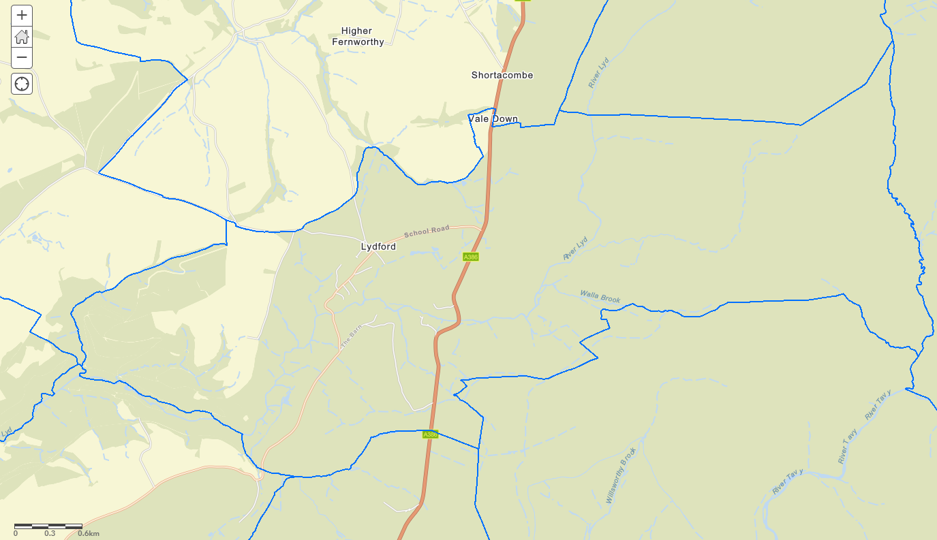

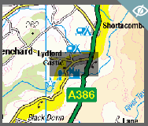
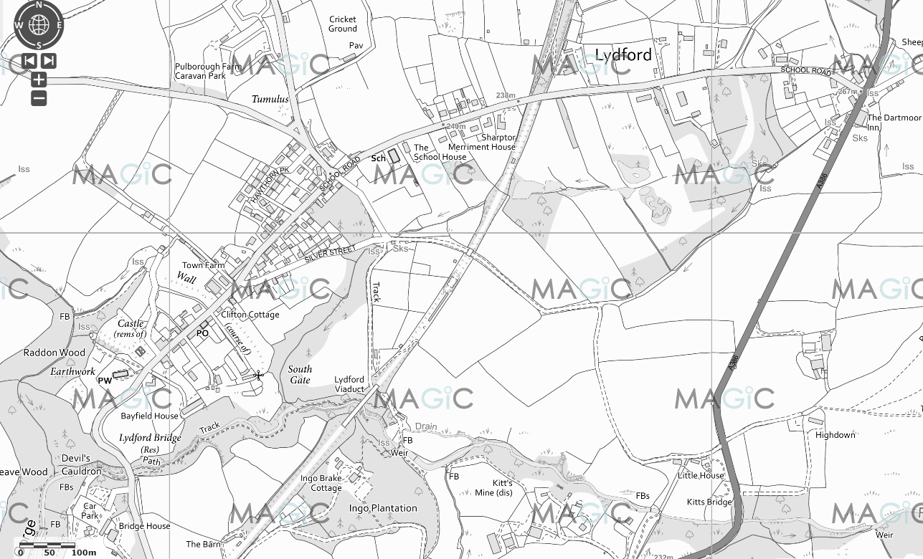
Key buildings Map 1
5
4
3
1
2
- Lydford Primary School (CS) 2. Sports Pavilion (2nd ICP) 3. Village Hall (ICP & CS) 4. Church 5. NT Lydford Gorge (Devils Cauldron)
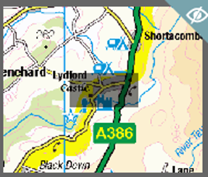
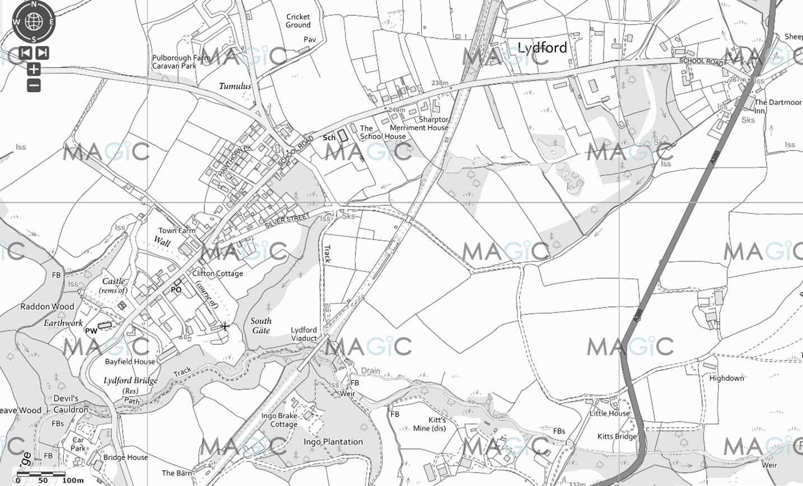
Key buildings Map 2
4
3
2
1
1. Castle Inn Pub 2. Caravan Park 3. Lydford House Hotel 4. Dartmoor Inn

Additional map identifying other key infrastructure items to be completed here – telephone exchange, sewage plant, vulnerable bridges and height restrictions

Annex D – Telephone tree notification system

A telephone tree is a group of people organised as a pyramid so that they can quickly and easily spread information. The coordinator at the top calls two people, who each call two more people until everyone in the list has been called. If someone is not available, the next person in the tree is called.

IN PRACTICE CURRENTLY NOT USED – EMAIL AND WHATSAPP

Community Emergency Coordinator

Contact number

Person (x)
Contact number
Person (x)
Contact number

Person (x)
Contact number
Person (x)
Contact number
Person (x)
Contact number
Person (x)
Contact number

Person (x)
Contact
number
Person (x)
Contact
number
Person (x)
Contact
number
Person (x)
Contact
number
Person (x)
Contact
number
Person (x)
Contact
number
Person (x)
Contact
number
Person (x)
Contact
number

Annex E – Activation procedure and logging sheet

Action |  | Complete
1 | If an emergency is possible or anticipated, monitor the situation and contact CRT members and warn the community. Be prepared to respond urgently.
2 | Dial 999 and ensure the emergency services are aware of the emergency and follow any advice given.
3 | Contact and inform your district/borough council.
4 | Record details on the log sheet on the other side of this page. Include:  • Decisions you have made and why  • Actions taken  • Who you spoke to and what you said  (Include contact numbers)  • Information received
5 | Contact other CRT members and the community by agreed method.  • Households affected  • Parish council/ward via the parish clerk  • Volunteers and key holders
6 | If needed, call a community meeting. Ensure the venue is safe and people can get there safely
7 | Take notes and record actions. If you decide to activate a plan, remember to follow the check sheet.
8 | When the emergency services arrive, the CRT Coordinator should introduce themselves and give them a copy of the plan.

Never do anything which outs you or anyone else in your community at risk

Log sheet

Record all information during an emergency. A log sheet is an easy way to ensure information is not lost and can help support/justify any decisions made or actions taken.

Date | Time | Information / Decision / Action | Initials

Annex F - Community flood plan

Community or group | Lydford
Address | All
Floodline quickdial number |  | NA

Which Environment Agency Flood Warnings are you registered to receive? | British Red Cross Alerts from environment agency

Local Flood Warning Triggers
i.e. when flood water reaches bottom of the bridge, sound siren or other action
Water coming back through drains on main street – rapidly becomes significant road hazard in central village and could enter houses.

Contents of Community Flood Plan Annex:

- Map showing flood risk areas and direction of flooding
- Actions to be taken before, during and after a flood
- After a flood: reputable contractors

1 – Map showing flood risks areas and direction of flooding

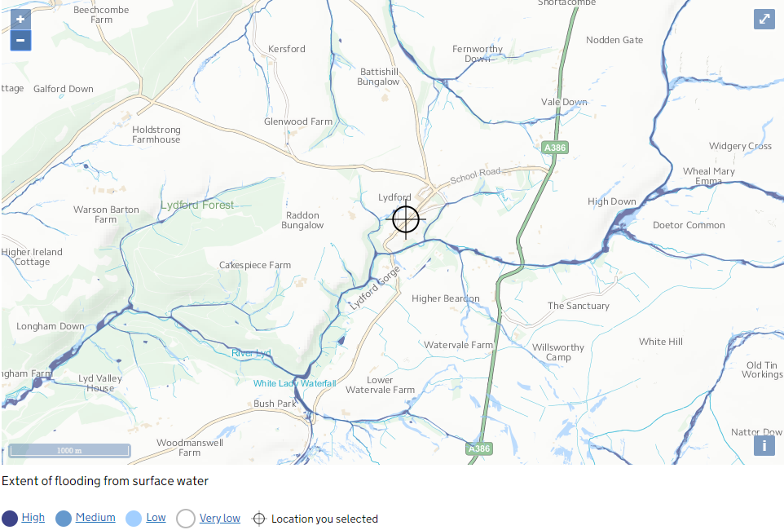

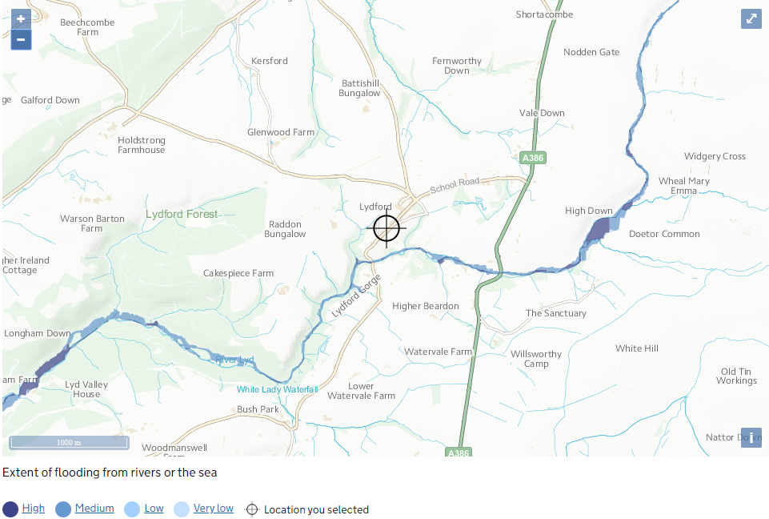

2. Actions to be taken before and during a flood

 | Before a flood |  |  |  | During a flood
Area number | Location at risk | Source | Triggers | Local actions | Actions | Equipment required | Time required
Area 1 | Any spot in central road of village | Surface water / blocked drains | Met office weather warning | Helpline  Publicize who to contact | Check authority to be contacted  Hazard sign up | Hi Vis Jackets  Hazard Sign  Sandbags (not many)? | Until drain block response
Responsibility for flooding and blockages
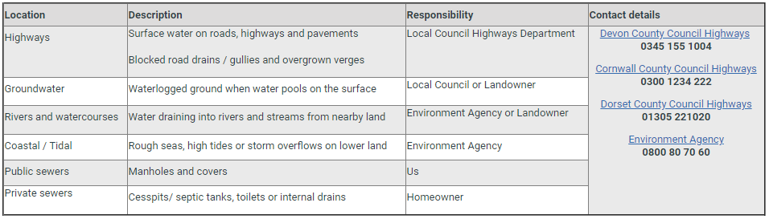
South west water
3 After a flood – reputable contractors

List companies/reputable contractors whose help you may need after a flood. Encourage residents and businesses to
1) take photos before the clean up as they may need to rely on them for insurance claims, and
2) ask their insurer before discarding items that can’t be cleaned, as they may want to make a claim for the items.

Get contracts in place or know who to call for assistance. If help is not needed, you can leave this section blank.

Point affected residents and businesses to this information:
- Get help after a flood (Environment Agency): https://www.gov.uk/prepare-for-a-flood/get-help-after-a-flood
- Support for flood victims (British Disaster Management Association): http://www.bdma.gov.uk/publications/flooddocs

Company name | Business type | Telephone | Fax/other

Only add details of contractors not already contained within Annex R2.

Annex G – Situation report (SITREP)

Use this form to record information about an emergency and give it to emergency responders. when they arrive.

Situation report
E | Exact location of the emergency
T | Type of emergency
H | Hazards present or suspected
A | Access – routes that are safe to use
N | Number, type and severity of casualties
E | Emergency services present?

Date:
Time:
Location:
Attendees:

Current situation?

Location of emergency. Is it near:
A school?
A vulnerable area?
A main access route?

Type of emergency:
Is there a threat to life?
Has electricity, gas or water been affected?

Are there any vulnerable people involved?
Elderly
Families with children

Resources needed? Food?
Off-road vehicles?
Blankets?
Shelter?

Establishing contact with the emergency services

How can we support the emergency services?

What agreed actions can safely be taken?

Agreed actions and leads?

Any other issues?

Annex H - Community resources (advised to redact)
List resources here e.g. community hall. THIS HAS BEEN REDACTED SEE R3

Annex I – Key contacts list (publicly available)

Category | Service/Name | Telephone Number | Additional Information
Emergency Services | Police | Emergency: 999  Non-Emergency: 101  Online reporting  www.devon-cornwall.police.uk/
 | Fire | Emergency: 999  Home safety visit: 0800 05 02 999  www.dsfire.gov.uk
 | Ambulance | Emergency: 999
 | Coastguard | Emergency: 999
Activation and Emergency Planning | Devon County  Council | https://www.devon.gov.uk/emergencies/  01392 382680 | Emergency Planning
Flooding and Forecasting | Environment Agency Flooding | Reporting / Advice  https://www.gov.uk/check-flood-risk
 | Met Office | https://www.metoffice.gov.uk/ | Meteorological forecasting
Utilities | South West Water | Operational queries helpline 0344 346 2020* (24 hours)  Freephone leak reporting helpline 0800 230 0561 (24 hr)  For blockages on a public sewer, please contact us on 0344 346 2020 so that we can confirm responsibility.  https://www.southwestwater.co.uk/ | Water and Sewage
 | Western Power Distribution | Power cut call 105 or 0800 6783 105  https://www.westernpower.co.uk/ | Power cuts
Healthcare | NHS Direct | 111  Add local surgery numbers | Advice
Highways | Devon County Council | Report a problem – including hazards  Emergency call 0345 155 1004  https://www.devon.gov.uk/roadsandtransport/report-a-problem/ | Highways management
Local Media | BBC Radio Devon | Main switchboard: 01752 260323  News desk: 01752 234511  Travel: 0345 300 2829
Animal Welfare | RSPCA | 24 hours: 0300 1234 999 for cruelty and neglect reporting  https://www.rspca.org.uk/utilities/contactus/reportcruelty
Emotional Support Services | Samaritans | 116 123 (24 hours)  https://www.samaritans.org/ | To talk about anything that is upsetting you
 | Victim Support | 08 08 16 89 111 (24 hours)  https://www.victimsupport.org.uk/ | Victims of crime
 | SANEline | 0300 304 7000 (4.30pm–10.30pm every day).  http://www.sane.org.uk/what_we_do/support/helpline | experiencing a mental health problem or supporting someone else
General | Other helplines | Locating other helplines for terminal illness support, families and carers and many other items see https://helplines.org/helplines/

All the above to be updated with Facebook and Twitter links.

Annex J –Establishing and operating a Community Shelter(s)

When an evacuation is needed, people will need a safe place. This safe place is the Community Shelter (CS).

Activation of a CS

A CS will be activated if the CRT decides that due to the emergency, it needs to provide shelter before the emergency services arrive.

Staffing the CS

Volunteers will be needed to staff the CS. The minimum requirement is shown below:

Serial post responsibilities

 | Post | Responsibilities
1 | Parish shelter coordinator | • Located at CS  • Manage shelter  • Provide feedback to ICP
2 | Receptionist 1 | • Staff reception desk  • Maintain register
3 | Receptionist 2 | As above
4 | Volunteer first aiders  (See Section 3 and Annex D) | • Provide basic first aid as required
5 | Volunteer cook | • Provide snacks/meals
6 | Volunteer evac. assistants | • Assist evacuees  • Issue blankets etc.

Evacuee information sheet
Please read this sheet as it contains information you will need about the Community Shelter.

Registration
Please register at the reception desk. You don’t have to register, but it is recommended, as it helps staff if any of your relatives are looking for you. Registration information is confidential.

Smoking and alcohol
Smoking and the consumption of alcohol is not permitted in the CS.

Personal belongings and children
We cannot assume responsibility for your belongings. Please keep valuable items with you. Parents are responsible for keeping track of and controlling their children. Please don’t leave them unattended.

Medical and injuries
If you have a medical condition that needs special consideration, i.e., heart condition, recent surgery, or pregnancy, please tell the staff. All medical information will be written on your registration card and is confidential.

Pets
We understand pets are part of your family. Unfortunately, our shelter may not be suitable for them. Tell us about your pets and we can help locate a temporary home for them where they will be well looked after. Registered Guide/Hearing Dogs are allowed within the CS.

Bulletin boards
Updates and bulletins will be put on a notice board for your information.

Volunteering and help
Evacuees are encouraged to help in the CS. Speak to the staff if you can help.

Telephones
We encourage you to tell a family member or friend where you are and ask them to tell others that may be worried about you. Please be considerate when using a mobile phone by speaking quietly.

Community Shelter(s) coordinator
Please listen to the coordinator and staff. They are the officials in the CS.

Problems and complaints
Please direct all comments about the CS operation to the coordinator.

News/media
News/media often visit the CS during an emergency. They may request interviews or photographs; however, they must ask your permission first. It is your right to refuse. Please report any problems or questions about the media to the coordinator.

Special needs/requirements
If you have any special needs, i.e. diet, health etc., please let the staff know.
If you require further information please ask any of the staff.

Annex K – Communications, warning and informing

Method | Location  (If applicable) | Contact / Responsibility | Additional information
Notice boards | Outside Parish Hall: PC Noticeboard | Asa MacIntyre | If non urgent via John Bright Parish Clark
 | Outside Parish Hall:  Village Noticeboard | Verify key holder
Local meeting | Village Hall if safe | PC: Stephen Squires  CRT: Asa Macintyre | Liaison with Jerry Lock for use of Hall
Parish Church Magazine | Printed | Sue Powne | Monthly
Local Business display | Lydford Farm Shop  Castle Inn  Dartmoor Inn | CRT member to request | See Annex R2 for named contacts
Community leaflets | Door to door | TBC | Develop as and when
Door Knocking | Door to door | TBC | Develop as and when
Facebook | Online | Asa / Ruth Tainsh / Chris Blackmore
Twitter | Online | Ruth Tainsh
Telephone cascade | To be developed

Key information such as road or school closures are usually reported on local radio.
Who | Where | What
BBC Radio Devon | 103.4 or 96.0FM | Local news / closures / Traffic
Lydford Village | Facebook | https://www.facebook.com/LydfordVillage

Twitter is an important source of immediate updates from Highways Agency, Okehampton and Tavistock police, Environment agency, Met office warnings, Defra and Devon Alert amongst others.

Annex L – Plan distribution

Redacted
Organisation | Contact details | Number issued
Parish Council | See Annex R2 | Email to all council
Neighbourhood Watch | Anthony Purnell  See Annex R2 | Email
Village Hall Committee | See Annex R2 | Email
Sports Field Committee | See Annex R2 | Email
Lydford School | See Annex R2 | Email
Lydford Gorge | See Annex R2 | Email
Lydford Church | Reverend Adrian Brooks  See Annex R2 | Email
Drop In | Sue Holland  See Annex R2 | Hard copy 1  (Delay)
Lydford Volunteer Group | Jodie Gilpin  See Annex R2 | Email
Cllr Caroline Mott
Cll Terry Southcott

Restricted

Organisation | Contact details | Number issued
Lydford CRT team | See earlier | R1
Devon Communities Together | Martin Rich for distribution to Local Resilience Forum | R2

Annex M - Glossary
Acronym/Term Definition
Bronze Command Operational Command
CEP Community Emergency Plan
CERT Community Emergency Response Team
CS Community Shelter
DCC Devon County Council
EA Environment Agency
CS Evacuation Assembly Point
EBC Evacuation Briefing Centre
EP Emergency Plan
Evac Evacuation
FAZ Flood Action Zone
FCP Forward Command Post
Gold Command Strategic Command
GR Grid Reference
HLS Helicopter Landing Site
ICP Incident Control Point
LHA Local Health Authority
xxxxDC xxx District Council
NHS National Health Service
SAR Search and Rescue
SDP Sandbag Distribution Point
SDP Controller Manages the filling and distribution of sandbags
Silver Command Tactical Command

Annex R1 – Vulnerable people (template only)
This list will constantly change, and different groups may become vulnerable during an emergency. Therefore, make a list following an emergency and give it to the emergency services and welfare agencies as soon as they arrive. Below is template for this. Consider different groups – elderly, complex needs, pregnant, children, language, visiting etc.

Name / Organisation | Telephone number | Address | Additional information

Annex R2 - Key contacts list (RESTRICTED)

Annex R4 COVID 19 response plan activated (general distribution)

Bullet draft – time spent on tasks – more detail available as required – in progress unless noted otherwise.

- Initially guided by Devon Community Resilience Forum presentation on Influenza Pandemic: Disseminate public messages; good neighbours; support people and reduce pressure on health and social services.
- Continue above but also:
  - Act as bridge between multiple bodies / groups and multiple groups / people parish – communicate relevant guidelines and resources to the correct groups / people as fast as they are developed and feed back required information to government agencies to help them.
  - Identify funding sources and process to access.
  - Work with neighbouring parishes to share ideas (1st link Bridestowe)
- Public message dissemination:
  - repeating and using material as possible on Facebook, Twitter, in Parish Mag and on noticeboard as appropriate – careful with static print as some guidelines e.g. home isolation change in relatively short periods. (CRT ongoing – started already) https://www.facebook.com/LydfordVillage/
  - Subscribed to Public Health England campaigns and have received latest material for leaflet, poster and digital media. In addition, have been using generic WHO material.
  - Repeat message and organized themes: Be safe, be kind, be smart. (Safe source material)
  - Possible need for leaflets on social isolation / social distancing guidelines but issue on speed of change / distribution. Possibly on request via helpline (See below)

Good neighbours / support / link with local government / resilience forum etc
- Existing support networks of people in village with neighbours of varying degrees of organization. Spoken with drop in but many other networks of supporting neighbours exist already
- Lydford Volunteer Network. Spontaneous volunteer group initially publicized on Facebook and now run through WhatsApp and emails. https://www.facebook.com/groups/660503728033288/ Emphasis on online organization not physical contact. CRT is not running this group but is working with founders closely re: guidelines / resources /registration (bridge role). Initial online or offline register of interest and then form registration (includes address / details etc) and initial guidelines on interaction (copy available). GDPR – destruction at end of incident unless requested NOT to do so by volunteer. Working with people with addresses in parish only. Network asks people to contact them or they work with other village groups e.g. Drop in who can use them as “legs” to do jobs if agreed by person.
- Church: CRT in communication with Vicar on related items.
- Village Hall: Communication of guidance re closure of social spaces. Additional social isolation needs – future plans. Some spontaneous activity occurring not yet liaised.
- Local business support: part of communication and part of signposting local support. Built into future phase plans. In village and neighbouring businesses have responded well to new needs – delivery services etc.
Lydford Helpline (set up and co-ordination): Initial number: 07572 785 522 (9am-8pm)
- What: Set up 2 Lydford Help signpost phone numbers and for those who are online: Email support and Facebook link to dedicated page of local resources on the Parish Council website.
- Why: Some people know who to call or have their own support networks. Others may need different resources to normal at this time because they are in quarantine due to having symptoms; self-isolating due to being vulnerable or living with a vulnerable person; dealing with emotional trauma and stress from the current situation.
- There are different groups / people and businesses offering different kinds of support at a local, regional and national level and the role we propose is to help make sure people can know where to go.
- The situation is very dynamic and different resources are being set up at different times and levels constantly. Difficult to update everyone in a “static” format e.g. parish mag or pamphlet and keep up with changes. However, if we set up this system we can update one Support Resource sheet and post it online (for those with online access) and update it to a relatively small and manageable group of people who can use it for phone support.
- In addition: a lot of people want to help – they can either join an existing group or they can set up their own thing and we can list them.
- Examples of Resource Sheet categories – NOTE 2 versions (online) and (helpline volunteer)
Name | What for / comment | How to contact
Medical questions | Dial 999 for an emergency. Go online to NHS 111 if you have internet access if not call 111
Lydford Volunteer group | Prescription pick up; Grocery pick up; Dog walking; Daily phone call – to check how you are and if you need something. | Contacts online and phone
Lydford Farm Shop | Deliveries of food from farm shop to doorstep. Pay by cash or cheque. Deliver next day normally. | Contacts online and phone
Reverend Adrian Brooks | Our local vicar. Note church services are cancelled except for funerals etc. but church is open for individual visiting. | Call:  Email:
Other local / government and national add as required. | E.g. Virtual social groups / Samaritans etc.

ACTIONS completed / in progress
- Email and main phone / phone number set up.
- Back up phone and SIM card ordered
- Text for pamphlet drop done and printed. Using Volunteer Network to distribute. They are notified and mapping sections now.
- Text for Parish magazine done – sending for distribution with magazine
- Place notice in notice board
- Set up dedicated page on PC website
- Facebook post goes up
- Draft Resource sheet up
- Updating and distribution of resource sheet (currently Ruth Tainsh)
- Rota of people prepared to “man” phone and back up phone and receive updated resource sheet (email is easiest). One phone marked Q will be used in Quarantine households, disinfected and only used in houses with no vulnerable people. Phone marked non Q will be used if any volunteers are considered vulnerable. Propose start on approx. 1 day per person on main phone or 3 days on back up phone (depends on volume may have to adjust). Easier if volunteers on email as well for resource sheet updates. Suggest keep group relatively small to keep everyone on the same script and ease of update. Keep up to date with guidance.
- Initial volunteers: (Stephen Squires; Asa Macintyre – would prefer to rapidly remove for other items); Anthony Purnell; Pip & Hugh Gascoyne; Katie & Richard Lenton; Jade and Oliver Curtis. Additional will be available – register and roster.
- Need to allocate “owner” for registration / rostering and ongoing management (possibly also updating).
- Requested information share with Bridestowe – Ruth to contact
- Additional benefit – system can be used for future emergencies

Also
- Guidance for cleaning of non – healthcare settings – consideration and link with Village Hall / Sports Pavilion and Church to be completed. Village toilets opening is cancelled until further notice.
- Working with South Hams & West Devon Councils volunteer coordination – guidance and registration
- Continue staying up to date with Lydford School – will it be open for key workers or going to different schools
- Working with Local Resilience Forum / Devon Communities Together to align and support
- Parish Council resilient – Zoom installed and emergency interim procedures agreed awaiting local government guidance

Annex R5 COVID 19 response plan outline (RESTRICTED)

